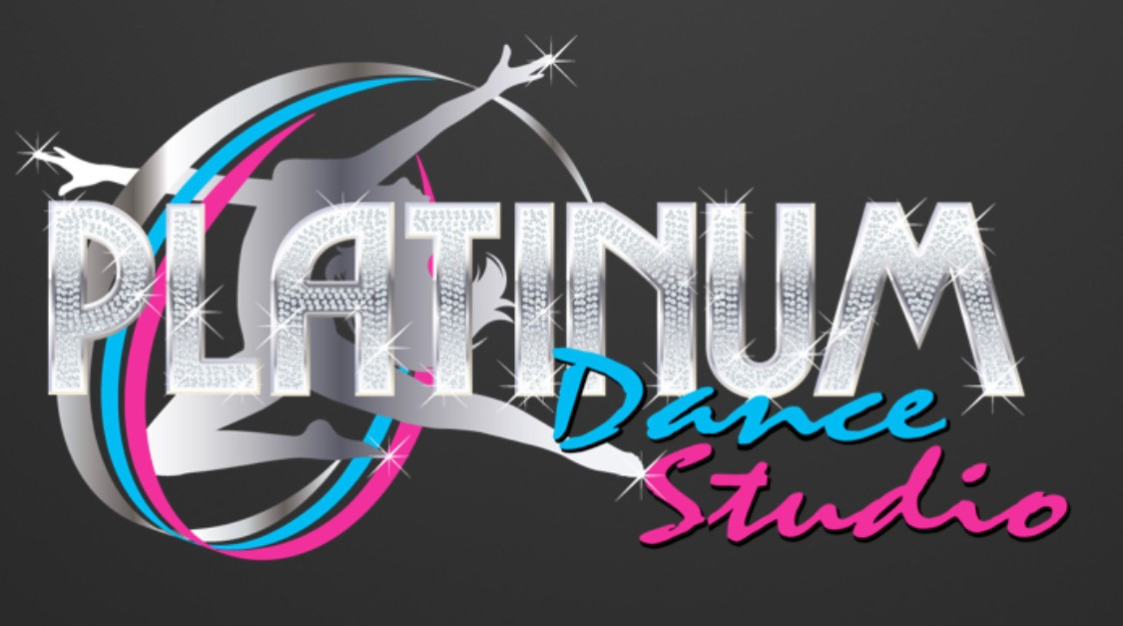 RECITAL ORDER FORM
Turn in by Saturday, May 1st, 2021

Dancer’s Name:
Name will be listed as printed above on program and t-shirt
Dancer Souvenir T Shirt:

(Circle one): Youth XS Youth S Youth M Youth L

Adult XS Adult S Adult M Adult L Adult XL

Additional Souvenir T Shirt: ($10.00 each)
Write quantity: ___Youth XS ___Youth S ___Youth M ___Youth L

___Adult XS ___Adult S ___Adult M ___Adult L ___Adult XL

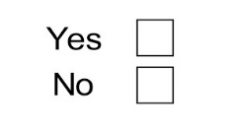
Souvenir Trophy: ($18.00 each)

Total due for additional items: $
*************************************************************************************
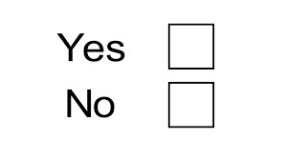
5 or 10 Year Award:
Is this your child’s 5th recital with Platinum Dance Studio?
Is this your child’s 10th recital with Platinum Dance Studio?

**************************************************************************************
Individual Photos:
Each class will take a group photo. If you would like your child to take individual photos please let us know which costumes/classes.

Day/Time/Teacher - Costume 1:

Day/Time/Teacher - Costume 2:

Day/Time/Teacher – Costume 3:

